Project Design Phase - II
Technology Stack (Architecture & Stack)

Date | 14 February 2026
Team ID | LTVIP2026TMIDS24427
Project Name | HematoVision: Advanced Blood Cell Classification Using Transfer Learning
Marks | 4 Marks

Technical Architecture:
HematoVision follows a three-tier technical architecture consisting of a web-based user interface, a backend processing layer, and an AI model layer. Users upload microscopic blood cell images through the web application, which are preprocessed and sent to a trained deep learning model (CNN/ResNet) for classification. The prediction results with confidence scores are then displayed to the user and optionally stored in the database for logging and administrative monitoring.
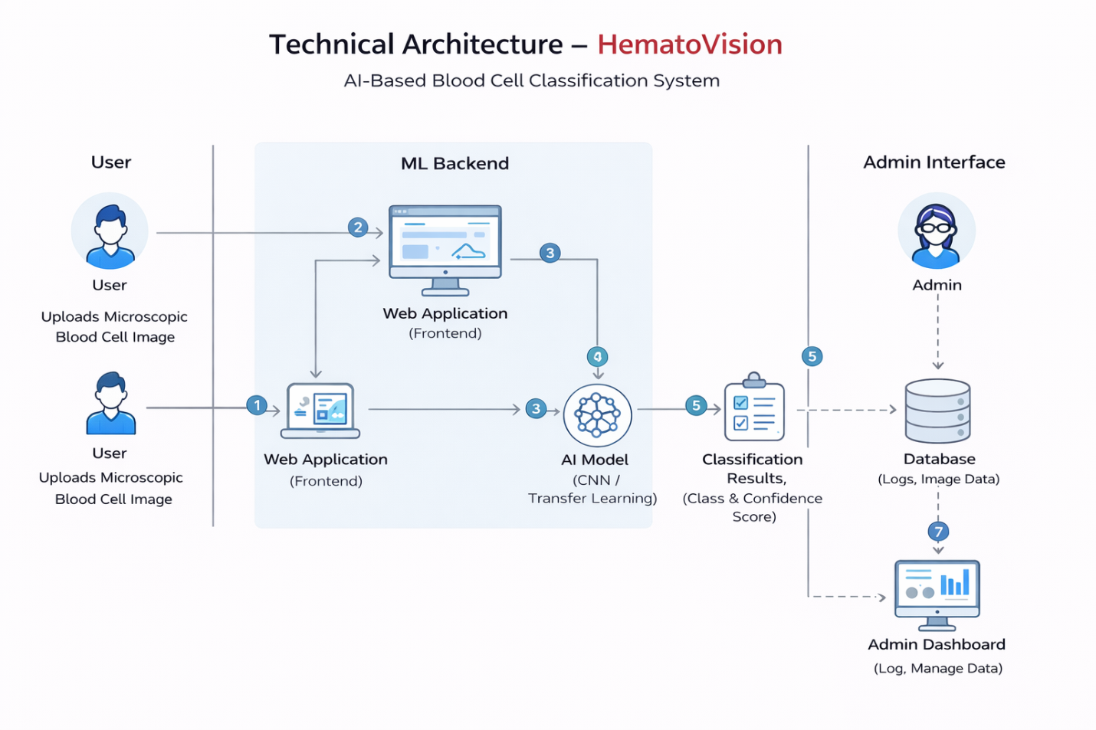

Table-1: Components & Technologies:
S.No | Component | Description | Technology
1 | User Interface | Web interface for users to upload blood cell images and view results | HTML, CSS, JavaScript
2 | Application Logic | Backend logic to handle image upload and prediction requests | Python, Flask (REST API)
3 | Image Preprocessing Module | Resizes, normalizes, and prepares images for model input | OpenCV, NumPy, PIL
4 | Machine Learning Model | Classifies blood cell images into categories (eosinophil, lymphocyte, monocyte, neutrophil) | TensorFlow / Keras, CNN, ResNet
5 | Prediction Engine | Generates prediction result with confidence score | TensorFlow Serving / Flask Integration
6 | Database | Stores user logs, prediction history, and system data | MySQL / SQLite
7 | File Storage | Temporary storage for uploaded blood cell images | Local Storage / Cloud Storage (AWS S3)
8 | Admin Dashboard | Interface to monitor predictions and model performance | HTML, CSS, JavaScript
9 | Model Management | Load, update, and retrain the trained deep learning model | Python, TensorFlow

Table-2: Application Characteristics:
S. No | Characteristics | Description | Technology Used
1 | Open-Source Frameworks | Frameworks used for building the application and AI model | Flask, TensorFlow, Keras, OpenCV
2 | Security Implementations | Secure image upload, API protection, and data handling | HTTPS, Input Validation, Authentication
3 | Availability | System accessible whenever server is active | Cloud Hosting / Local Server
4 | Performance | Fast image processing and prediction generation | Optimized CNN Model, GPU Support
5 | Reliability | Provides consistent and accurate classification results | Trained CNN Model with Validation
6 | Maintainability | Easy model updates and retraining capability | Modular Python Code Structure
7 | Usability | Simple and user-friendly web interface | Responsive Web Design

